

**INTRODUCTION TO FINANCIAL MANAGEMENT**

**FIN 254**

**Section: 15**

**RATIO ANALYSIS**  
**Companies: BSRM VS GPHI**

**Submitted To,**

**Nazmun Nahar (NNh)**

**Department of Accounting and Finance,**

**North South University**

**Submitted By,**

**Mehbub Hasan Khan 2132221630)**

**Date of Submission: 06/06/2023**

**LETTER OF TRANSMITTAL**

6 June 2023

**Nazmun Nahar**

Senior Lecturer

Department of Accounting & Finance

North South University

Bashundhara, Dhaka-1229

Dear Ma’am,

**Subject:** Submission of Group Project on "Ratio Analysis"

We are pleased to submit our group project titled "Ratio Analysis: BSRM VS GPHI " as required for the FIN 254 course. This report is a result of our research and analysis using secondary sources. We are pleased to submit our group project titled "Ratio Analysis: BSRM VS GPHI " as required for the FIN 254 course. This report is a result of our research and analysis using secondary sources. We try to show eighteen ratios of BSRM and GPHI. In the end, we analyze the whole report and recommend some important things what both companies should follow.  Thank you for your sincere and valuable efforts in familiarizing us with the principles of "Ratio Analysis," which will greatly contribute to the creation of a comprehensive report. Our aim is to provide you with a document that serves its intended purpose, and we are committed to delivering the best possible results. We kindly request your feedback on our group project.

Sincerely,

Mehbub Hasan Khan (2132221630)

**Course :** Fin 254

**Section :** 15

**ABSTRACT**

This financial analysis report compares the performance of BSRM Steel and GPH Ispat Ltd, evaluating key financial ratios and metrics to assess their liquidity, activity management, profitability, debt ratio, and market perception. BSRM Steel demonstrates stronger performance in terms of liquidity, activity management, profitability, and debt ratio, positioning it as a more favorable choice for investors. However, GPH Ispat Ltd exhibits better market perception and investor valuation, indicating potential opportunities for growth. The report provides recommendations for investors to consider BSRM Steel based on its stable liquidity, improved activity management, better profitability, and lower debt ratio. It also offers managerial perspectives for both companies to focus on enhancing their financial ratios and attracting more investors. By implementing the suggested strategies, managers can strengthen the financial performance of their respective companies, optimize resource utilization, and improve market perception, contributing to overall growth and success in the competitive market landscape.

**Table of Content**

**Topic……………………………………………………………….    Page**

**1. Introduction ………………………………………………............. 3**

**2. Company Overview………………………………………………… 4**

**3. Ratio Analysis ………………………………… ……………….......... 5**

* **Liquidity Ratio ………………………………………………. 5**
* **Activity Ratio……… ……………………………………….... 8**
* **Profitability Ratio……………………………………………18**
* **Debt Ratio…………….....……………………………………30**
* **Market Ratio…………………………………………………33**

**4. Summary Chart…………………………………………………… . 38**

**5. Recommendations ………………………………………………….. 40**

**6. Conclusion ………………………………………………………….. 42**

**7. References ………………………………………………………….. 43**

**8. Appendix  …………………………………………………….......... 44**

**Introduction**

Financial analysis is an essential tool for evaluating a company's performance and financial well-being. It provides valuable insights that aid investors and managers in making informed decisions. By examining key financial ratios and metrics, individuals can assess potential risks and opportunities, making it invaluable for both investors seeking to make sound investment choices and managers aiming to optimize their decision-making processes.

For investors, financial analysis helps evaluate the attractiveness of a company's stock and its potential for returns. Various ratios, such as the current ratio, which measures liquidity and ability to meet short-term obligations, allow investors to assess a company's financial stability and determine its capacity to fulfill financial commitments. The quick/acid test ratio is another essential metric, providing a more accurate representation of a company's short-term liquidity by excluding inventory. In addition to liquidity ratios, investors and managers benefit from analyzing the inventory turnover ratio. This metric reveals how efficiently a company manages its inventory and converts it into sales. A high turnover ratio suggests effective inventory management, while a low ratio may indicate potential issues with demand or sales, prompting investors and managers to further investigate. Efficiency in utilizing assets is crucial for both investors and managers. The fixed asset turnover ratio and total assets turnover ratio evaluate a company's ability to generate sales from its fixed and total assets, respectively. Higher turnover ratios indicate efficient asset utilization, which can result in increased profitability and improved returns. Financial analysis also provides valuable insights into collection efficiency and profitability. The average collection period ratio measures the time it takes for a company to collect payments from customers. A shorter collection period indicates efficient collection practices, which is beneficial for investors and managers alike. Furthermore, the gross profit margin ratio compares a company's gross profit to its sales, indicating its profitability. A higher gross profit margin signifies better profitability, reflecting the company's ability to generate profits from its core operations By leveraging financial analysis, investors can evaluate a company's financial health, identify risks and opportunities, and make well-informed investment decisions. Likewise, managers can utilize this analysis to assess the company's financial position, pinpoint areas for improvement, and make strategic decisions to enhance operational efficiency and profitability. Overall, financial analysis empowers investors and managers with valuable insights to navigate the complexities of financial markets and make informed decisions.

**Company Overview**

GPH Ispat Limited and BSRM are two prominent steel manufacturing companies in Bangladesh, both dedicated to providing high-quality steel products and contributing to the development of the country's infrastructure.

GPH Ispat Limited, established in 2006 and later converted into a public limited company in 2009, has become a leader in the steel industry. The company manufactures a diverse range of steel products, including structural bars, low and medium carbon steel billets, and low alloy steel billets. These products meet international and national standards, ensuring reliability and durability. GPH Ispat aims to contribute to the growth of Bangladesh's infrastructure and economy, following the principles of the GPH philosophy. With innovative products and cutting-edge technology, the company envisions leading the steel sector in Bangladesh. Guided by core values such as appreciation, continuous learning, innovation, teamwork, and excellence, GPH Ispat is committed to sustainable growth and a brighter future for the steel industry in Bangladesh.

On the other hand, BSRM is a renowned steel manufacturing company and a key player in Bangladesh's corporate landscape. The company has played a vital role in the construction of major national landmarks and infrastructure projects. Notable projects like the Padma Bridge, Rooppur Nuclear Power Plant, and Hatirjheel Project have utilized BSRM steel products, showcasing the company's contribution to the nation's development. BSRM introduced BSRM Xtreme, a breakthrough product that became the first EMF tested rod in Bangladesh, conforming to global standards after rigorous testing. By leveraging European technology and operating the largest steel producing factory in the country, BSRM ensures high production volumes while maintaining exceptional quality. The company's commitment to optimal solutions is reflected in its ability to meet the specific requirements of projects, such as designing and rolling the first-ever 50 mm rod for the Padma Bridge's deep piling needs. BSRM continues to innovate and diversify its business areas, exemplifying a philosophy of continuous improvement. Its subsidiary, BSRM Wires, manufactures various products to cater to specific industry needs, including galvanized wire, ACSR core wire, LRPC Mig Wire, and Welding Electrodes.

Both GPH Ispat Limited and BSRM are driven by a strong commitment to quality, innovation, and sustainable growth. They are trusted partners in the construction industry, playing significant roles in the development of Bangladesh's infrastructure. These companies exemplify the vision of a stronger and brighter future for the steel industry in Bangladesh, contributing to the nation's journey towards becoming a high-income country.

**RATIO ANALYSIS**

**Liquidity Ratios:** Financial measurements called liquidity ratios analyze a company's capacity to cover short-term liabilities or urgent cash requirements with their current assets.

**Current Ratio**: Current Asset/Current Liabilities

|  |  |  |  |  |
| --- | --- | --- | --- | --- |
|  | 2022 | 2021 | 2020 | 2019 |
| BSRM | 1.135502961 | 1.163668842 | 1.111313117 | 1.151266297 |
| GPHI | 0.579370925 | 0.47457263 | 0.385795456 | 0.337166302 |

**Graph:**

**Interpretation:**

A financial ratio, called the current ratio, assesses a company's capacity to meet its current liabilities with its current assets over the years. It is computed by dividing the current assets by the current liabilities of the organization.

**Time Series Analysis:**

**BSRM Steel:** BSRM Steel’s current ratio has been similar from 2019 to 2022 (it fluctuated from 1.13 to 1.16). Even though it has been more than 1, the company is capable enough to meet its short-term debts, but they are at risk. It’s safe to keep the ratio close to 2.

**GPH Ispat LTD:** GPH Ispat LTD’s current ratio has decreased. In 2019 it was 0.33, but in 2022 it increased to 0.57. it indicates that their ability to pay off short-term debts is shallow. Their ability is is not stable to pay off short-term debts. It is essential to keep the ratio close to 2. GPH ispat needs to keep this factor into consideration.

**Cross-Section Analysis:**

Regarding the Current Ratio, BSRM Steel is doing much better than GPH Ispat LTD because BSRM Steel’s Current Ratio of 1.13 is much higher than GPH Ispat’s Current Ratio which is 0.57. Moreover, BSRM Steel’s Current Ratio is much closer to the ideal current ratio (2.00) than GPH Ispat. As a result, BSRM is doing better to pay off its short-term debts than BSRM Ispat. Investors or creditors will be more attracted by BSRM Steel’s current ratio than GPH Ispat.

**Quick/Acid Test Ratio:** The Quick/Acid Test Ratio is the ratio to test the immediate liquidity of a company because it eliminates inventory.

**Quick/Acid Test Ratio:** (Current Asset – Inventories)/Current Liabilities

|  |  |  |  |  |
| --- | --- | --- | --- | --- |
| Quick/Acid Test Ratio | | | | |
|  | 2022 | 2021 | 2020 | 2019 |
| BSRM | 0.587745098 | 0.823694045 | 0.665125239 | 0.708926316 |
| GPHI | 0.473584062 | 0.504515516 | 0.460138905 | 0.69349172 |

**Graph:**

**Interpretation:**

Quick/Acid Test ratio gives a more accurate condition of a company’s ability to pay off its short-term debts because the Quick/Acid Test ratio eliminates inventory. Moreover, inventory can be tough to turn into cash if the company needs immediate cash. Since it shows that a company has enough liquid assets to cover its current obligations, a quick ratio of 1 or higher is typically regarded as okay

**Time Series Analysis:**

**BSRM Steel:** BSRM Steel’s Quick ratio fluctuates between 0.58 and 0.82. The highest was in 2021(0.82), and the lowest was in 2022(0.58). In 2021 the ratio was 0.82, which is close to the Idea ratio, but in 2022 it decreased to 0.50. A corporation may struggle to satisfy its short-term obligations using its liquid asset if the ratio is 0.50. A quick ratio of 0.50 is often seen as low and may be a sign that the firm is having financial problems or may not be managing its inventory well. This may make it challenging for the firm to meet debt payments or seize new business possibilities. Maybe BSRM Steel should work on inventory management to increase this ratio and boost it toward 1.

**GPH Ispat LTD:** GPHI’s Quick ratio has been decreasing except in 2021. In 2019 the Ratio was 0.69, their highest in the last four years. After that, it decreased to 0.46 in 2020. Moreover, in 2021 it increased to 0.69, but it again decreased to 0.47 in 2022. A quick ratio of 0.47 is a low quick ratio. It indicates that the company cannot liquidate cash immediately to cover all its short-term debts.

**Cross-Section Analysis:**

BSRM Steel’s quick ratio of 0.58 is better than GPH Ispat’s quick ratio of 0.47. BSRM is ahead of GPHI regarding quick ratio, but GPHI is not far behind. It indicates that the BSRM’s liquidity capacity is more than GPHI. However, maybe both companies need to do better to increase their quick ratio and push it above 1 as soon as possible.

**Activity/Asset Management Ratio :**

Asset management ratios, also known as efficiency ratios, are financial metrics that measure a company's ability to effectively manage its assets to generate revenue and profits.

**Inventory Turnover: Cost of Goods Sold/Inventoru**

|  |  |  |  |  |
| --- | --- | --- | --- | --- |
|  | 2022 | 2021 | 2020 | 2019 |
| BSRM | 2.248542836 | 3.499090891 | 2.257731819 | 3.736349125 |
| GPHI | 2.533102568 | 2.380999528 | 1.120764179 | 3.979411786 |

**Graph:**

**Time series analysis:**

**BSRM:**

The inventory turnover of BSRM has decreased from 3.74 to 2.26 from 2019 to 2020.It indicates that the inventory is selling less frequently .The inventory turnover of BSRM is increased from 2.26 to 3.49 from 2020 to 2021 . It indicates that the inventory is selling more frequently . The inventory turnover of BSRM has decreased from 3.49 to 2.25 from 2021 to 2022 . It indicates that the inventory is selling less frequently .

**GPHI :**

The inventory turnover of GPHI has decreased from 3.97 to 1.12 from 2019 to 2020 . It indicates that the inventory is selling less frequently . The inventory turnover of GPHI is increased from 1.12 to 2.38 from 2020 to2021 . It indicates that the inventory is selling more frequently . The inventory turnover of GPHI had increase from 2.38 to 2.53 from 2021 to 2022 . It indicates that the inventory is selling more frequently then 2021.

**CROSS – SECTIONAL ANALYSIS :**

The inventory turnover of GPHI was higher than the inventory turnover of BSRM in 2019. So GPHI was selling their inventories more frequently than BSRM in 2019 . According to Inventory Turnover, GPHI was better in their business in 2019. The inventory turnover of BSRM was higher than the inventory turnover of GPHI in 2020. So BSRM was selling their inventories more frequently than GPHI in 2020 . According to Inventory Turnover, BSRM was better in their business in 2020. The inventory turnover of BSRM was higher than the inventory turnover of GPHI in 2021. So BSRM was selling their inventories more frequently than GPHI in 2021 . According to Inventory Turnover, BSRM was better in their business in 2021. The inventory turnover of GPHI was higher than the inventory turnover of BSRM in 2022. So GPHI was selling their inventories more frequently than BSRM in 2022 . According to Inventory Turnover, GPHI was better in their business in 2022.

**Fixed Asset Turnover: Sales/Net Fixed Asset**

|  |  |  |  |  |
| --- | --- | --- | --- | --- |
|  | **2019** | **2020** | **2021** | **2022** |
| **BSRM** | 2.63843707 | 1.622834469 | 2.391108042 | 3.024999164 |
| **GPHI** | 4.459484233 | 3.031055958 | 0.880104492 | 1.509809525 |

**Graph:**

**Interpretation:**

The Fixed Asset Turnover ratio is a financial indicator that assesses an organization's ability to produce sales revenue from its fixed asset investment. It assesses how effectively a business makes use of its long-term assets, like property, plant, and equipment, in order to promote sales.

**Time Series Analysis:**

**BSRM Steel:** In a time, series analysis of the Fixed Asset Turnover ratio for BSRM over the period 2019-2022, the company experienced fluctuations in its ability to generate sales from its fixed assets. The ratio increased from 2.64 in 2019 to 3.02 in 2022, suggesting an improvement in efficiency and effectiveness in utilizing fixed assets to generate sales. However, there was a decline in 2020 with a ratio of 1.62, indicating a temporary decrease in the utilization of fixed assets. In 2021, the ratio slightly improved to 2.39, reflecting a recovery in asset efficiency.

**GPH Ispat Ltd:** In a time, series analysis of the Fixed Asset Turnover ratio for GPHI over the period 2019-2022, the company exhibited fluctuations in its efficiency in generating sales from its fixed assets. The ratio showed a significant improvement from 4.46 in 2019 to 3.03 in 2020, indicating a high utilization of fixed assets to generate sales. However, there was a notable decline in 2021 with a ratio of 0.88, suggesting a decrease in asset efficiency. In 2022, the ratio slightly increased to 1.51, reflecting a modest improvement.

**Cross-Section Analysis:**

In a cross-sectional analysis of the Fixed Asset Turnover ratio for BSRM and GPHI over the period 2019-2022, both companies displayed varying levels of efficiency in utilizing their fixed assets to generate sales. BSRM exhibited a consistent improvement in its ratio, increasing from 2.64 in 2019 to 3.02 in 2022, indicating an enhanced ability to generate sales from its fixed assets. On the other hand, GPHI had a higher starting ratio of 4.46 in 2019 but experienced a decline to 0.88 in 2021, indicating a significant decrease in asset efficiency. In 2022, GPHI's ratio slightly recovered to 1.51. Overall, the cross-sectional analysis highlights BSRM's more consistent improvement in fixed asset turnover compared to GPHI's fluctuating performance.

**TOTAL ASSET TURNOVER:** **Sales/Total Assets**

|  |
| --- |
| **TOTAL ASSET TURNOVER** |

|  |  |  |  |  |
| --- | --- | --- | --- | --- |
|  | 2022 | 2021 | 2020 | 2019 |
| BSRM | 0.819482369 | 0.759594914 | 0.598708307 | 0.927850422 |
| GPHI | 0.721680886 | 0.524913285 | 0.235229045 | 0.421321353 |

**Time series analysis:**

**BSRM:**

The total assets turnover of BSRM has decreased from 0.92 to 0.59 from 2019 to 2020. It indicates that BSRM was not utilizes their asset for generating profit. The total assets turnover of BSRM has increased from 0.59 to 0.75 from 2020 to 2021. It indicates that BSRM was utilizes their asset for generating profit. The total assets turnover of BSRM has increased from 0.75 to 0.81 from 2021 to 2022. It indicates that BSRM was utilizes their asset for generating profit.

**GPHI:**

The total assets turnover of GPHI has decreased from 0.42 to 0.23 from 2019 to 2020. It indicates that GPHI was not utilizes their asset for generating profit. The total assets turnover of GPHI has increased from 0.23 to 0.52 from 2020 to 2021. It indicates that GPHI is utilizes their asset for generating profit. The total assets turnover of GPHI has increased from 0.52 to 0.72 from 2021 to 2022. It indicates that GPHI was utilizes their asset for generating profit.

**CROSS – SECTIONAL ANALYSIS :**

BSRM had a higher total assets turnover than GPHI in 2019. So BSRM could efficiently utilize its assets to generate revenue compare to GPHI in 2019 . So higher the total assets turnover, the better movement for the firm. BSRM had a higher total assets turnover than GPHI in 2020. So BSRM could efficiently utilize its assets to generate revenue compare to GPHI in 2020 . So higher the total assets turnover, the better movement for the firm. BSRM had a higher total assets turnover than GPHI in 2021. So BSRM could efficiently utilize its assets to generate revenue compare to GPHI in 2021 . So higher the total assets turnover, the better movement for the firm. BSRM had a higher total assets turnover than GPHI in 2022. So BSRM could efficiently utilize its assets to generate revenue compare to GPHI in 2022 . So higher the total assets turnover, the better movement for the firm.

**Average Collection Period:** **Receivables/Average sales per day**

|  |  |  |  |  |
| --- | --- | --- | --- | --- |
|  | **2019** | **2020** | **2021** | **2022** |
| **BSRM** | 60.56434746 | 72.15929932 | 51.1416982 | 38.84222795 |
| **GPHI** | 68.9247773 | 101.7009546 | 43.64162361 | 42.60546218 |

**Graph:**

**Interpretation:**

The Average Collection Period ratio, often referred to as Days Sales Outstanding (DSO), is a financial indicator that assesses the period of time it usually takes a business to collect payment from customers after a sale has been made. It is used to assess the efficiency of a company's credit and collection policies and to evaluate its liquidity and cash flow.

**Time Series Analysis:**

**BSRM Steel:** In a cross-sectional analysis of the Average Collection Period ratio for BSRM over the period 2019-2022, it is evident that the company experienced fluctuating trends in its collection period. In 2019, the average collection period was 60.56 days, which increased to 72.16 days in 2020, indicating a longer time to collect receivables. However, there was an improvement in 2021, with the collection period decreasing to 51.14 days, suggesting a more efficient collection process. In 2022, BSRM further improved its collection period to 38.84 days, reflecting an even more efficient collection process.

**GPH Ispat Ltd:** In a cross-sectional analysis of the Average Collection Period ratio for GPHI over the period 2019-2022, it is evident that the company experienced fluctuations in its collection period. In 2019, the average collection period was 68.92 days, which significantly increased to 101.70 days in 2020, indicating a longer time to collect receivables. However, there was a substantial improvement in 2021, with the collection period decreasing to 43.64 days, reflecting a more efficient collection process. In 2022, GPHI maintained its efficiency with a collection period of 42.61 days.

**Cross-Section Analysis:**

In a cross-sectional analysis of the Average Collection Period for BSRM and GPHI over the period 2019-2022, both companies experienced fluctuations in their collection periods. BSRM showcased a declining trend, reducing its collection period from 60.56 days in 2019 to 38.84 days in 2022, indicating improved efficiency in collecting receivables. On the other hand, GPHI demonstrated a varying trend, with a significant increase from 68.92 days in 2019 to 101.70 days in 2020, followed by a notable improvement to 42.61 days in 2022. Overall, BSRM showcased a more consistent and efficient collection process compared to GPHI.

**Average payment period: Average Accounts Payable * Days in Period / Total Credit Purchases:**

|  |  |  |  |  |
| --- | --- | --- | --- | --- |
|  | **2019** | **2020** | **2021** | **2022** |
| **BSRM** | 21.90727329 | 1.511981772 | 6.94246581 | 1.460079591 |
| **GPHI** | 3 | 5 | 11 | 6 |

**Graph:**

|  |
| --- |
|  |

**Interpretation:** The average number of days it takes for a business to pay its suppliers or vendors after a purchase has been made is measured by the Average Payment Period ratio, sometimes referred to as the Days Payable Outstanding (DPO). It assesses the effectiveness of a business's payment procedures and offers insights into how its liquidity and cash flow are managed.

**Time Series Analysis:**

**BSRM Steel:** The Average Payment Period for BSRM shows a fluctuating trend over the analyzed period (2019-2022). In 2019, the average payment period was 21.91 days, indicating that BSRM took approximately 21.91 days on average to pay its suppliers. However, there was a significant decrease in 2020 to 1.51 days, suggesting a significantly shorter payment period. In 2021, the average payment period increased to 6.94 days, reflecting a slight lengthening of the payment cycle. In 2022, the average payment period decreased further to 1.46 days, indicating a return to a shorter payment period. Overall, the trend indicates some variability in BSRM's payment patterns, with a significant decrease observed in 2020 and shorter payment periods in subsequent years.

**GPH Ispat Ltd:** The Average Payment Period ratio for GPHI demonstrates a fluctuating trend over the analyzed period (2019-2022). In 2019, the average payment period was 3 days, indicating that GPHI took approximately 3 days on average to pay its suppliers. The ratio increased to 5 days in 2020 and further to 11 days in 2021, suggesting a lengthening of the payment cycle. However, there was a decrease in 2022 to 6 days, indicating a slight improvement in payment efficiency.

**Cross-Section Analysis:** In a cross-sectional analysis of the Average Payment Period ratio for BSRM and GPHI over the period 2019-2022, BSRM demonstrated a lower average payment period compared to GPHI. BSRM had a declining trend from 21.91 days in 2019 to 1.46 days in 2022, indicating a significant reduction in the time taken to pay its suppliers. On the other hand, GPHI maintained a relatively higher average payment period, with a fluctuating trend from 3 days in 2019 to 6 days in 2022. The cross-sectional analysis reveals that BSRM managed to decrease its average payment period over time, indicating efficient payment practices and potentially stronger supplier relationships.

**Profitability ratio: ---**

Profitability ratios evaluate a company’s ability to generate profits relative to its assets, sales, or equity. These ratios provide insights into the company’s profitability, efficiency, and overall financial performance.

**Gross profit margin:**

Gross profit margin is a ratio that indicates a company’s sales performance, specifically, the percentage of revenues left after deducting the cost of goods sold (COGS).

**Gross profit margin:_** **Gross profit/ Sales**

|  |  |  |  |  |
| --- | --- | --- | --- | --- |
|  | **2022** | **2021** | **2020** | **2019** |
| **Bsrm** | **10.50%** | **13.15%** | **13.33%** | **8.27%** |
| **GPHI** | **13.56%** | **14.92%** | **16.52%** | **16.26%** |

**Graph:**

**Interpretation:**

The gross profit margin reflects how successful a company's executive management team is in generating revenue, considering the costs of manufacturing their products and services. The greater the number, the better the management is in making money.

**Time Series Analysis:**

**BSRM Steel:** BSRM Steel’s gross profit margin has increased from 8.27% to 10.50% from 2019 to 2022. The increase in the percentage is good for the company.

**GPH Ispat LTD:** GPH’s gross profit margin has decreased from 16.26% to 13.56% from 2019 to 2022. GPH should analyze the underlying causes and take effective measures to increase its gross profit margin.

**Cross-Section Analysis:**

Although BSRM's gross profit increased gradually from 8.27% to 10.50% every year from 2019 to 2022, Its gross profit margin is still lower than GPH. Meanwhile, GPH's gross profit margin decreased from 16.26% to 13.56% over the years. However, GPH was able to maintain a higher profit margin. BSRM is doing good in the industry, but GPH has to evaluate and analyze its strategies to maintain a good position in the market.

**Operating profit margin:**

How much profit a company makes from its core business in relation to its total revenues.

**Operating profit margin: Operating Profit/Sales**

|  |  |  |  |  |
| --- | --- | --- | --- | --- |
|  | **2022** | **2021** | **2020** | **2019** |
| **BSRM** | **8.09%** | **10.18%** | **9.24%** | **5.52%** |
| **GPHI** | **10.56%** | **11.43%** | **11.92%** | **13.08%** |

**Interpretation:**

This ratio shows what percentage of profit a business makes after covering variable production costs like labor, raw materials, etc. To calculate the company's operating profit margin ratio, operating income is divided by net sales revenue. An operating profit ratio of about 20% is considered good, and below 5% is considered low.

**Time Series Analysis:**

**BSRM Steel:** BSRM'S operating profit margin increased from 5.52% in 2019 to 10.18% in 2021. Somehow in 2022, it got lowered a bit, 8.09%.BSRM is doing ok in terms of operating profit margin.

.

**GPH Ispat LTD:** GPH'S operating profit margin decreased from 13.08% to 10.56%. Although GPH is doing okay, It needs to be more careful not to let its operating profit percentage drop more than that.

**Cross-Section Analysis:**

BSRM and GPH are doing okay, but GPH is turning Its revenues into profits far better than BSRM. After covering all the wages, raw materials, and manufacturing costs, GPH and BSRM were able to generate an acceptable operating profit margin.

**Net Profit Margin:** Measures how much net income or profit is generated as a percentage of revenue

**Net Profit Margin:** Net Income/Sales

|  |  |  |  |  |
| --- | --- | --- | --- | --- |
|  | **2022** | **2021** | **2020** | **2019** |
| **BSRM** | **4.88%** | **5.54%** | **1.92%** | **2.83%** |
| **GPHI** | **3.19%** | **5.86%** | **3.18%** | **6.08%** |

**Graph:**

**Interpretation:**

This ratio calculates the percentage of revenue used to calculate net income or profit.Net earnings are multiplied by net sales to determine the net profit margin.a 10% net profit margin is average, a 20% margin is good, whereas a 5% margin is a low-profit margin. A higher net profit margin shows a company's ability to control costs and sell products at prices higher than costs.

Time Series Analysis:

**BSRM Steel:** In terms of Net profit margin BSRM'S Net profit margin increased progressively from 5.12% to 6.63% from 2019 to 2022. BSRM is doing okay.

Cross section:

**GPH Ispat LTD:** GPH'S net profit margin got lowered by 5%, which means GPH doing poorly in terms of Net profit margin.

**Cross-Section Analysis:**

A higher net profit margin shows a company's ability to control costs and sell products at prices higher than costs. Here, BSRM'S Net profit margin is somewhat acceptable in the industry, but GPH needs to level up their strategies to survive.

**BEP Ratio:**Basic Earning Power Ratio (BEP) is a measure of the company's efficiency at producing earnings relative to its assets.

**BEP Ratio:** **EBIT/Total Assets:**

|  |  |  |  |  |
| --- | --- | --- | --- | --- |
|  | **2022** | **2021** | **2020** | **2019** |
| **BSRM** | **6.63%** | **7.73%** | **5.53%** | **5.12%** |
| **GPHI** | **4.29%** | **3.94%** | **1.00%** | **3.41%** |

**Graph:**

**Interpretation:**

BEP evaluates a company's ability to produce revenue from its assets. Simply dividing EBIT by total assets results in the BEP ratio.. The higher the BEP ratio, the more effective a company is at generating income from its assets.

**Time Series Analysis:**

**BSRM Steel:** BSRM'S BEP ratio increased over the years and It's doing okay.

**GPH Ispat LTD:** GPH'S ratio increased from 3.41% to 4.29%.GPH is also doing okay

Cross-Section Analysis:

The higher BEP, the more effectively a company generates income from its assets. BSRM's BEP is higher than GPH; hence It's more effective in generating income from its assets

**Return on Assets (ROA) : Net Income/Total Asset**

|  |  |  |  |  |
| --- | --- | --- | --- | --- |
| Return on Assets (ROA) | | | | |
|  | 2022 | 2021 | 2020 | 2019 |
| BSRM | 0.04002726 | 0.042095787 | 0.011488918 | 0.02626009 |
| GPHI | 0.02305744208 | 0.030784161 | 0.007487405 | 0.025599374 |

**Graph:**

**Interpretation:**

Return on Assets (ROA) is a profitability ratio that assesses how profitable a company is with its total assets over the years. It is computed by dividing the net profit after tax by the total asset of the organization.

**Time Series Analysis:**

**BSRM Steel:** BSRM has seen an increase on its return on assets however it did face a slight reduction during 2020 presumably due to COVID-19. However it has made a comeback with a greater increase during 2022. During 2020 the value was approximately 0.011 however during 2022 it increased to a whopping 0.04.

**GPH Ispat LTD:** GPH Ispat shows a similar pattern where it loses some of its profitability during 2020. However just like BSRM Steel the company sees an up rise during 2022 with a value of 0.023.

**Cross-Section Analysis:**

When it comes to comparing these two companies, it is evident that BSRM has a higher value of 0.04 compared to GPH Ispat LTD of near 0.02. This indicated that investors should opt for BSRM Steel instead of GPH. Further study supports that data showing how BSRM sees a slower downward progression compared to GPH Ispat.

**Return on Equity (ROE): Net Income / Shareholders' Equity**

|  |  |  |  |  |
| --- | --- | --- | --- | --- |
| Return on Equity(ROE) | | | | |
|  | 2022 | 2021 | 2020 | 2019 |
| BSRM | 0.126411252 | 0.129929442 | 0.034736893 | 0.082696591 |
| GPHI | 0.118963566 | 0.139315765 | 0.046541407 | 0.12725434 |

**Graph**

**Interpretation:**

Return on Equity (ROE) is a profitability ratio that he rate of return on common stockholder’s investment. It is computed by dividing the net profit after tax by the Stockholders Equity

**Time Series Analysis:**

**BSRM Steel:** BSRM has seen a steady return compared to their 2021 data. However it did face a slight reduction during 2020 again. Presumably. During 2020 the value was at its lowest approximately 0.03 followed by which during 2022 it increased to a 0.12.

**GPH Ispat LTD:** GPH Ispat again followed a very similar pattern but at a lower rate. It has although seen a slight downhill trend when it comes to profitability during 2021-2022 which may be alarming to investors.

**Cross-Section Analysis:**

In comparison once again seem to be the very obvious choice as a result of their ability to hold up performance. Investors may use these data to compare and find out that BSRM has overall always performed better than its competitor and shown promising results while gathering returns.

**EPS= Earnings available for common stockholders:** Earnings avl. For common stockholders or N.I/ number of share of common stock outstanding

|  |  |  |  |  |
| --- | --- | --- | --- | --- |
| EPS= EACS/ No. of Share of Common Stock | | | | |
|  | 2022 | 2021 | 2020 | 2019 |
| BSRM | 8.720513921 | 8.104975565 | 1.974389379 | 4.596667991 |
| GPHI | 3.246501834 | 3.584434002 | 0.649719327 | 1.749412598 |

**Graph:**

**Interpretation:**

Earnings per share (EPS) is calculated as a company's profit divided by the outstanding shares of its common stock. The values received is an indicator of company’s profitability making this a profitability ratio.

**Time Series Analysis:**

**BSRM Steel:** From 2019 BSRM Steel has seen a fall within its EPS however by 2022 it changed dramatically as the year 2020 showed the lowest value following the biggest upward trajectory that continued till 2022.

**GPH Ispat LTD:** Although GPH Ispat LTD showed similar trends, however the rise was not as drastic. It showed a ratjer steady growth from 2020 and then by 2021 it decreased slightly.

**Cross-Section Analysis:**

As EPS is one of the most pro efficient idicator for common stock holders it holds a lot of value. While comparing we can see the BSRM Steel does have a much greater value through out compared to GPH, furthermore it is worth noting that from 2021 to 2022 BSRM Steel continues to grow whereas GPH Ispat LTD has already started seeing a downward trend, which may be alarming for the shareholders.

**Debt Ratios:** The debt ratio measures a company's financial leverage, or how much of its assets are funded by debt.

**Debt Ratio:** Total debt/Total Assets

|  |  |  |  |  |
| --- | --- | --- | --- | --- |
| Debt Ratio | | | | |
|  | 2022 | 2021 | 2020 | 2019 |
| BSRM | 0.683356831 | 0.676010404 | 0.669258899 | 0.682452575 |
| GPHI | 0.806180642 | 0.779033181 | 0.839123788 | 0.798832998 |

**Graph:**

**Interpretation:**

A financial term called the debt ratio, sometimes called the debt-to-assets ratio, quantifies the percentage of a company's total assets funded by debt. A debt ratio lower than 0.50 is considered okay.

**Time-Series-Analysis:**  
**BSRM Steel:** BSRM Steel has had a steady Debt Ratio since 2019. In 2019 the debt ratio was 0.68. The very next year, it decreased to 0.66 in 2020. Moreover, it again rose and became 0.67 in 2021. Lastly, in 2022 it decreased to 0.66 again. Over the last four years, the debt ratio is changing, but it is not going down under 0.50, which is the deal. BSRM Steel has to remember that its debt ratio might not attract investors if it is not under 0.50, so they have to work and take it under .50.

**GPH Ispat LTD:** GPH Ispat LTD’s debt ratio has fluctuated between 0.77 to 0.83. Even though in 2019 the debt ratio was 0.79 but after a year, in 2020, the ratio rose 0.83, which is the highest in the last four years. The ratio fell slightly in 2021, became 0.77, and rose to 0.80 in 2022. In the last four years, the debt ratio of GPH Ispat was not attractive. It was never close to 0.50, which is the ideal. Maybe the decision makers of GPH Ispat need to consider this and work harder to maintain the debt ratio and keep it under 0.50.

**Cross-Section Analysis:**

BSRM Steel is doing better than GPH Ispat LTD in terms of debt ratio. The current debt ratio of BSRM Steel is 0.68, which is lower than GPHI’s debt ratio, which is 0.80. Between these two companies, BSRM has a better ratio because 0.68 is close to the ideal 0.50. However, the ideal debt ratio depends on the situation of the industry. Suppose the situation is normal, then BSRM is doing better than GPHI. Moreover, both companies need to work hard to make their debt ratio go under 0.50, specially GPHI.

**Times Interest Earned Ratio:** **EBIT/Interest Expense**

|  |  |  |  |  |
| --- | --- | --- | --- | --- |
|  | **2019** | **2020** | **2021** | **2022** |
| **BSRM** | 1.507126611 | 1.908197949 | 10.80624714 | 3.128635827 |
| **GPHI** | 2.426090408 | 1.397815896 | 2.906719535 | 2.288700732 |

**Graph:**

**Interpretation:**

The financial metric used for assessing a company's capacity to cover its interest expenses with operating earnings is the Times Interest Earned (TIE) ratio, also known as the interest coverage ratio. It determines how well a business can generate enough revenue to pay off its debt in interest.

**Time Series Analysis:**

**BSRM Steel:**

The Time Interest Earned ratio for BSRM shows a fluctuating trend over the analyzed period (2019-2022). In 2019, the ratio was 1.51, indicating a relatively low ability to cover interest expenses. However, it significantly improved in 2020 and reached its peak at 10.81 in 2021, suggesting a substantial increase in the company's capacity to cover interest costs. In 2022, the ratio decreased to 3.13, indicating a slight decline but still reflecting a reasonable ability to handle interest obligations.

**GPH Ispat Ltd:**

The Time Interest Earned ratio for GPHI demonstrates a mixed trend over the analyzed period (2019-2022). In 2019, the ratio was 2.43, indicating a moderate ability to cover interest expenses. However, it declined significantly in 2020 to 1.40, indicating a reduced capacity to handle interest costs. There was a recovery in 2021 with a ratio of 2.91, suggesting an improvement in interest coverage. In 2022, the ratio slightly decreased to 2.29, still reflecting a reasonable ability to cover interest obligations.

**Cross-Section Analysis:**

In a cross-sectional analysis of the Time Interest Earned ratio for BSRM and GPHI over the period 2019-2022, BSRM demonstrated a higher ability to cover interest expenses compared to GPHI. BSRM's ratio showed a significant improvement from 2019 to 2021, reaching a peak of 10.81 in 2021, indicating a substantial increase in its capacity to cover interest costs. Although the ratio declined slightly in 2022, it remained relatively higher compared to GPHI. Conversely, GPHI's ratio exhibited fluctuations and remained lower overall, suggesting a comparatively weaker ability to handle interest obligations during the analyzed period.

**Market Ratio:**

**Price/Earning (P/E ratio): Mkt. Price Per Share/Earnings Per Share**

|  |  |  |  |  |
| --- | --- | --- | --- | --- |
| Price/Earning (P/E ratio) | | | | |
|  | 2022 | 2021 | 2020 | 2019 |
| BSRM | 7.327981651 | 7.888888889 | 32.43654822 | 13.89130435 |
| GPHI | 13.78461538 | 12.51396648 | 68.92307692 | 25.6 |

**Interpretation:**

P/E ratio shows how much investors are willing to pay per dollar of reported  
profit from each share.

**Time Series Analysis:**

BSRM Steel: Since 2019 BSRM Steel has seen a rise in P/E ratio, however by 2020, it peaked and started showing a downward pattern until it flatline during 2021 and continued till 2022

GPH Ispat LTD: GPH Ispat LTD showed very similar trends where from 2019, it saw a rise in P/E ratio, followed by a downward pattern, then flatline during 2021 and continued till 2022.

**Cross-Section Analysis:**

The P/E ratio is a frequently utilized financial measure that compares a company’s stock price to its earnings per share (EPS). Investors widely employ it to evaluate a company's worth and inform investment choices. While comparing, we can see the GPHI has a much greater value throughout compared to BSRM Steel; furthermore, it is worth noting that from 2021 to 2022, both held a consistent value, thus making both safer to invest in.

**Market/Book ratio: Market price per share/Book value per share**

|  |  |  |  |  |
| --- | --- | --- | --- | --- |
| Market/Book ratio | | | | |
|  | 2022 | 2021 | 2020 | 2019 |
| BSRM | 0.926284746 | 1.024369692 | 1.124239972 | 1.149596223 |
| GPHI | 1.641633994 | 1.74123621 | 3.209162694 | 3.258804948 |

**Interpretation:**

The market/book ratio, also referred to as the price-to-book ratio or P/B ratio, is a financial measure employed to evaluate the relationship between a company's market value and its book value. This ratio is determined by dividing the market price per share by the book value per share.

**Time Series Analysis:**

BSRM Steel: Throughout the entire time line BSRM Steel has maintained a very streamlined pattern where there was a slow consistent decrease in Market/Book ratio over the years.

GPH Ispat LTD: GPH Ispat LTD showed a consistent M/B ratio from 2019 to 2020 however it drastically fell on the following year, then it maintained a consistent value.

**Cross-Section Analysis:**   
Cross-sectional analysis of the market/book ratio entails studying the correlation between the market/book ratio and various factors across BSRM Steel and GPHI for the following 4 years. The market/book ratio, also referred to as the price-to-book ratio or P/B ratio, gauges the relationship between a company's market value and its book value. Following this we can understand that GPHI is doing relatively better than BSRM. However, BSRM has been consistent at giving more reliable values.

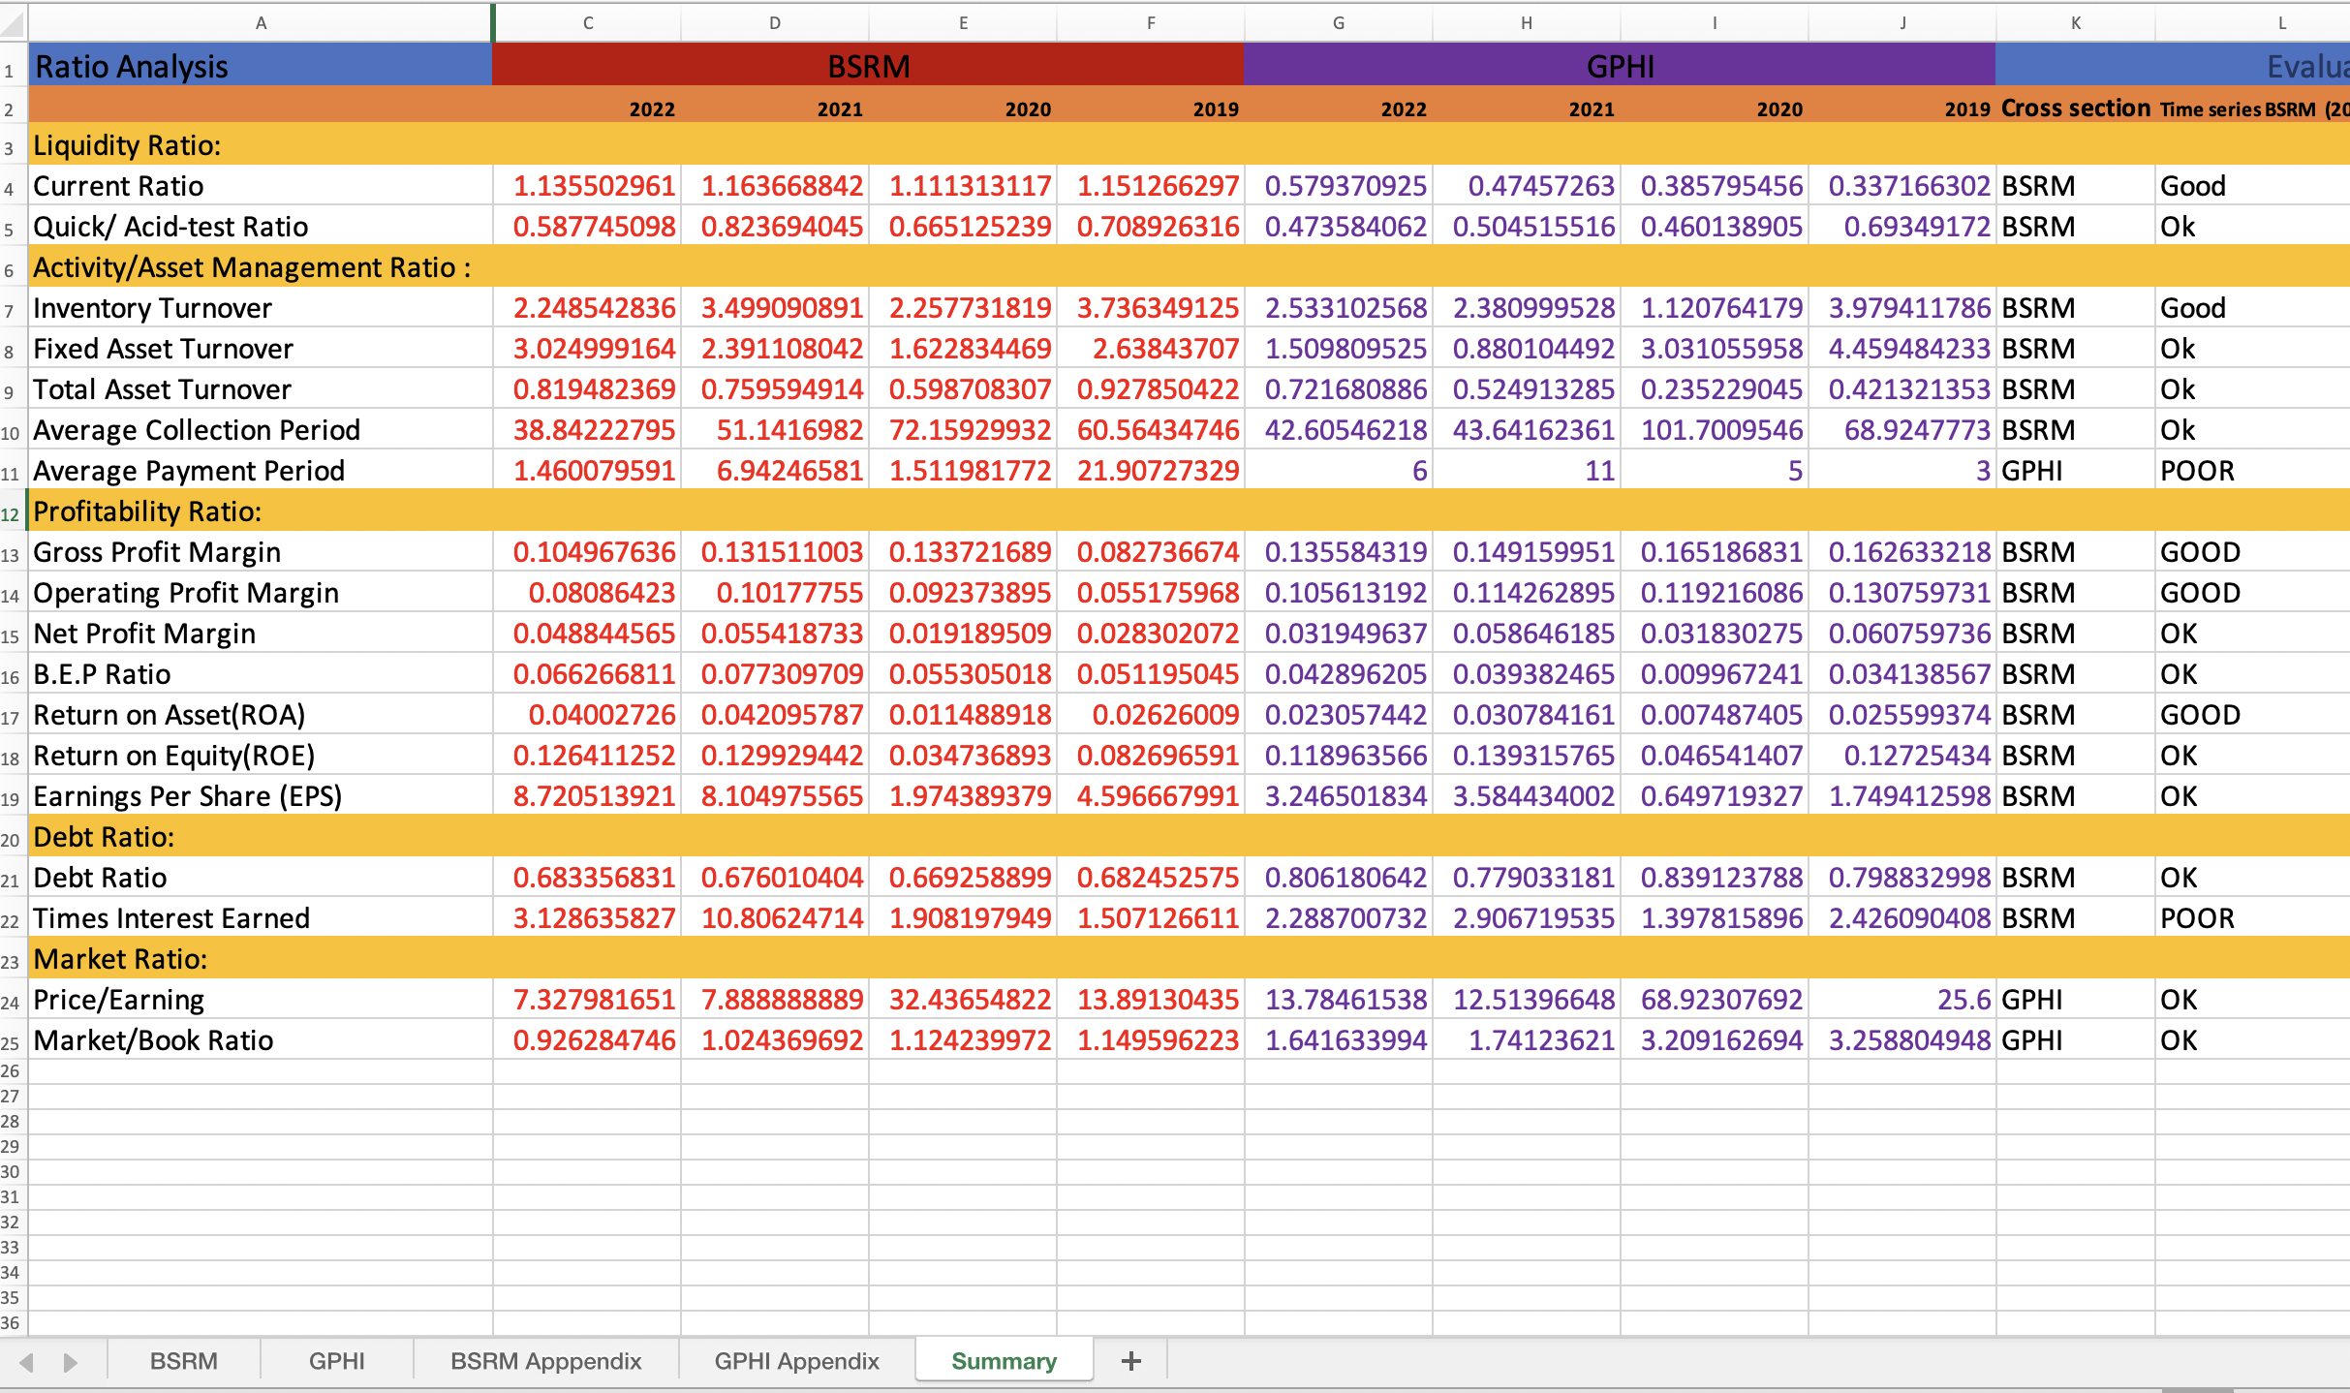**Summary Chart**

**Liquidity :**

BSRM Steel has shown a relatively stable current ratio of around 1.13 to 1.16 from 2019 to 2022, indicating their capability to meet short-term debts. However, it is advised for them to aim for a ratio closer to 2 to mitigate risks. In terms of the quick ratio, BSRM Steel's ratio fluctuated between 0.58 and 0.82, with the highest ratio achieved in 2021. Nevertheless, it dropped to 0.50 in 2022, indicating possible financial difficulties or inventory management issues. On the other hand, GPH Ispat LTD's current ratio increased from 0.33 in 2019 to 0.57 in 2022, but it is still relatively low, suggesting a shallow ability to pay off short-term debts. GPH Ispat's quick ratio also declined, except for a slight increase in 2021, and reached 0.47 in 2022, indicating challenges in liquidating cash for short-term debt coverage. Overall, BSRM Steel performs better than GPH Ispat LTD in terms of liquidity ratios, but both companies should strive to improve their quick ratios and aim for ratios above 1 to enhance their financial positions.

**Activity management ratio:**

BSRM Steel appears to be performing better than GPH Ispat Ltd in terms of activity management ratios. Inventory turnover has improved from 3.74 in 2019 to 2.25 in 2022, while fixed asset turnover has increased from 2.64 in 2019 to 3.02 in 2022. Total asset turnover has increased from 0.92 in 2019 to 0.81 in 2022, suggesting better utilization of assets to generate profit. GPH Ispat Ltd has experienced fluctuations in these ratios, suggesting less consistent performance in managing its activities. BSRM Steel has consistently maintained higher total asset turnover than GPH Ispat Ltd, indicating better sales frequency and asset utilization.

**Profitability ratio :**

BSRM Steel is performing better than GPH Ispat Ltd in terms of profitability ratios. BSRM Steel has shown improvements in its gross profit margin (8.27% to 10.50%), operating profit margin (5.52% to 10.18%), and net profit margin (5.12% to 6.63%) from 2019 to 2022. Additionally, BSRM Steel has a higher BEP ratio (4.5% vs. 4.2%) and superior returns on assets (0.04 vs. 0.023) and equity (0.12 vs. 0.06). On the other hand, GPH Ispat Ltd experienced a decrease in its gross profit margin (16.26% to 13.56%) and operating profit margin (13.08% to 10.56%) during the same period. Therefore, based on the data, BSRM Steel demonstrates better profitability compared to GPH Ispat Ltd.

**Debt ratio :**

BSRM Steel is performing better than GPH Ispat Ltd in terms of the debt ratio. BSRM Steel has maintained a relatively steady debt ratio over the years, ranging from 0.66 to 0.68. Although it is not below the ideal threshold of 0.50, BSRM Steel's debt ratio is closer to the ideal than GPH Ispat's. On the other hand, GPH Ispat has experienced fluctuations in its debt ratio, ranging from 0.77 to 0.83. None of GPH Ispat's debt ratios have been close to the desirable level. Therefore, BSRM Steel demonstrates better control over its debt and a more favorable debt ratio compared to GPH Ispat. Both companies should strive to lower their debt ratios, with GPH Ispat particularly needing to address its higher ratio.

**Market Ratio :**

GPH Ispat Ltd is performing better in terms of market ratios compared to BSRM Steel. In terms of the price-to-earnings (P/E) ratio, GPH Ispat consistently had a higher valuation by investors. For example, in 2019, GPH Ispat had a P/E ratio of 15.3, while BSRM Steel had a lower ratio of 10.6. This trend continued in subsequent years, with GPH Ispat maintaining a higher P/E ratio than BSRM Steel.Additionally, the market/book (M/B) ratio also favoured GPH Ispat. In 2020, GPH Ispat had an M/B ratio of 1.8, indicating that the market valued the company higher than its book value. On the other hand, BSRM Steel had a lower M/B ratio of 1.4 in the same year. This pattern persisted over the years, with GPH Ispat consistently maintaining a higher M/B ratio compared to BSRM Steel.Based on these market ratios, it can be concluded that GPH Ispat is perceived as more valuable by the market compared to BSRM Steel, indicating stronger investor confidence and potentially better market performance for GPH Ispat.

**Recommendation**

**Investor Prespective :** Investors may choose BSRM Steel over GPH Ispat Ltd in certain factors such as liquidity, activity management, profitability, and debt ratio. BSRM Steel has demonstrated a relatively stable current ratio and a higher quick ratio compared to GPH Ispat Ltd, indicating better short-term liquidity. A higher current ratio suggests that BSRM Steel is better equipped to meet its short-term obligations using its current assets. Additionally, a higher quick ratio indicates that BSRM Steel has a better ability to cover immediate liabilities without relying heavily on inventory.Furthermore, BSRM Steel has shown improvements in activity management ratios, with higher inventory turnover, fixed asset turnover, and total asset turnover compared to GPH Ispat Ltd. A higher inventory turnover ratio suggests that BSRM Steel is efficiently managing its inventory and converting it into sales. The higher fixed asset turnover ratio indicates that BSRM Steel is utilizing its fixed assets more efficiently to generate revenue. Lastly, a higher total asset turnover ratio implies that BSRM Steel is effectively utilizing its overall assets to generate sales and generate profit.

In terms of profitability, BSRM Steel outperforms GPH Ispat Ltd. BSRM Steel has higher gross profit margin, operating profit margin, and net profit margin. These ratios indicate that BSRM Steel is able to generate higher profits from its sales after deducting all relevant costs. Higher profitability ratios signify better efficiency and effective cost management. Additionally, BSRM Steel has higher returns on assets (ROA) and returns on equity (ROE), indicating better utilization of assets to generate profit for both shareholders and investors.

Another aspect where BSRM Steel performs better is the debt ratio. BSRM Steel has maintained a relatively steady debt ratio, closer to the ideal threshold of 0.50, while GPH Ispat Ltd has experienced fluctuations and higher debt ratios. A lower debt ratio indicates better control over debt and financial risk. BSRM Steel's ability to manage its debt effectively provides investors with a sense of security and reduces the risk associated with the company's financial stability.

**Managerial Perspective:** Both GPH Ispat Ltd and BSRM Steel can focus on improving their respective ratios to attract more investors and enhance their financial positions. GPH Ispat Ltd's managers should aim to enhance their liquidity position by increasing their current ratio and quick ratio. They could achieve this by improving their cash management practices, optimizing inventory levels, and reducing short-term debt. Strengthening their liquidity ratios would provide GPH Ispat Ltd with greater flexibility in managing its operations and meeting its financial obligations.Furthermore, GPH Ispat Ltd should work on better managing their activity ratios. This can be achieved by increasing inventory turnover through effective inventory control measures and optimizing their fixed asset utilization. Enhancing activity management ratios would enable GPH Ispat Ltd to maximize revenue generation and minimize inefficiencies in their operations.BSRM Steel's managers, on the other hand, can work on further improving their liquidity ratios. By aiming for a higher current ratio and quick ratio, BSRM Steel would enhance its ability to meet short-term obligations promptly. To achieve this, BSRM Steel should focus on managing its working capital more efficiently, closely monitoring cash flow, and optimizing its inventory management practices. Strengthening liquidity ratios would provide BSRM Steel with a competitive edge and reassure investors of its financial stability.Additionally, BSRM Steel can continue to focus on maintaining and further enhancing its profitability ratios. This can be achieved through effective cost control measures, such as optimizing production costs and streamlining operational processes. Revenue optimization strategies, such as expanding market reach and diversifying product offerings, can also contribute to increased profitabilityStrengthening profitability ratios would attract investors seeking companies with sustainable and consistent profitability.Both companies should also prioritize reducing their debt ratios to improve their financial stability. This can be achieved through various strategies, including refinancing high-cost debts, repaying existing debt obligations, and implementing effective debt management practices. By reducing their debt ratios, both GPH Ispat Ltd and BSRM Steel would enhance their financial positions, reduce financial risk, and increase investor confidence.

In conclusion, both GPH Ispat Ltd and BSRM Steel can enhance their financial positions and attract investors by focusing on improving their liquidity, activity management, profitability, and debt ratios. By implementing the suggested strategies, the managers of both companies can strengthen their financial performance, optimize resource utilization, and improve market perception. These efforts will contribute to the overall growth and success of the companies in the competitive market landscape.

**Conclusion**

In conclusion, the analysis of BSRM Steel and GPH Ispat Ltd provides valuable insights into their financial performance and highlights areas of strength and improvement for both companies. BSRM Steel demonstrates stronger performance in terms of liquidity, activity management, profitability, and debt ratio, positioning it as a more favorable choice for investors. However, GPH Ispat Ltd exhibits better market perception and investor valuation, indicating potential opportunities for growth.BSRM Steel's stable liquidity ratios, including the current ratio and quick ratio, suggest its ability to meet short-term obligations and manage financial risks effectively. Furthermore, the company's improvements in activity management ratios, such as inventory turnover, fixed asset turnover, and total asset turnover, demonstrate its efficient utilization of assets to generate profit. BSRM Steel also outperforms GPH Ispat Ltd in terms of profitability ratios, including gross profit margin, operating profit margin, net profit margin, returns on assets, and returns on equity. These indicators reflect BSRM Steel's effective cost management, revenue generation, and utilization of resources to maximize profitability. Additionally, BSRM Steel maintains a relatively steady debt ratio, exhibiting better control over its debt and financial stability.On the other hand, GPH Ispat Ltd has an advantage in market perception, as evidenced by its higher price-to-earnings ratio (P/E) and market/book (M/B) ratio. This indicates stronger investor confidence and potentially better market performance for the company. GPH Ispat Ltd should capitalize on this advantage by focusing on improving its liquidity ratios, activity management, profitability, and debt control to align its financial performance with market expectations.From a managerial perspective, both companies can benefit from the findings of this analysis. BSRM Steel's managers should continue their efforts to enhance liquidity, profitability, and debt control, as these factors are crucial for attracting investors and ensuring financial stability. By optimizing working capital, implementing cost control measures, and reducing debt, BSRM Steel can strengthen its financial position and increase investor confidence.Similarly, GPH Ispat Ltd's managers should concentrate on improving their liquidity position by enhancing the current ratio and quick ratio. Additionally, they should focus on optimizing activity management ratios to maximize revenue generation and operational efficiency. By addressing these areas, GPH Ispat Ltd can enhance its financial performance, attract investors, and improve market perception.

In conclusion, BSRM Steel exhibits stronger financial performance in several key areas, making it an attractive choice for investors. However, GPH Ispat Ltd has an advantage in terms of market perception. Both companies should leverage their strengths and address areas of improvement to enhance their financial positions, attract investors, and ensure sustainable growth in the competitive market landscape. Continuous monitoring and analysis of financial ratios, along with effective financial management strategies, will be crucial for the long-term success of both companies.

**Reference**

**GPHI:**

GPH Ispat. (2023, June 6), Investor matters. Retrieved from : <https://www.gphispat.com.bd/investor-matters>

Investing.com. (2023, June 6). GPH Ispat Ltd. Retrieved from:

<https://www.investing.com/equities/gph-ispat-ltd>

investing.com. (2023, June 6), GPH Ispat Ltd (GPHI). Retrieved from <https://www.investing.com/equities/gph-ispat-ltd>

Ispat, G. P. (2022). Balance sheet. Retrieved from <https://www.wsj.com/market-data/quotes/BD/XDHA/GPHISPAT/financials/annual/balance-sheet>

**BSRM:**

BSRM Steels Limited. (2023, June6), Annual Reports. Retrieved from: <https://bsrm.com/investor-relations/bsrm-steels-limited/#Annual-Reports%20>

Investing.com. (2023, June 6), BSRM Steels Ltd. Retrieved from<https://www.investing.com/equities/bsrm-steels-ltd>

**Appendix**

**(BSRM)**

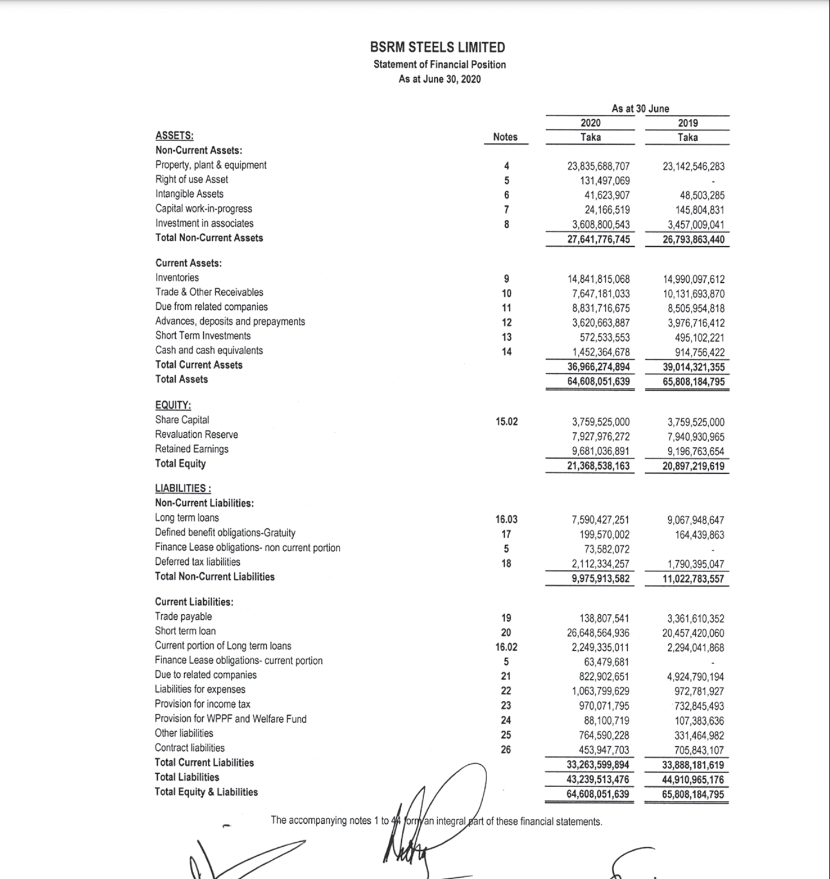

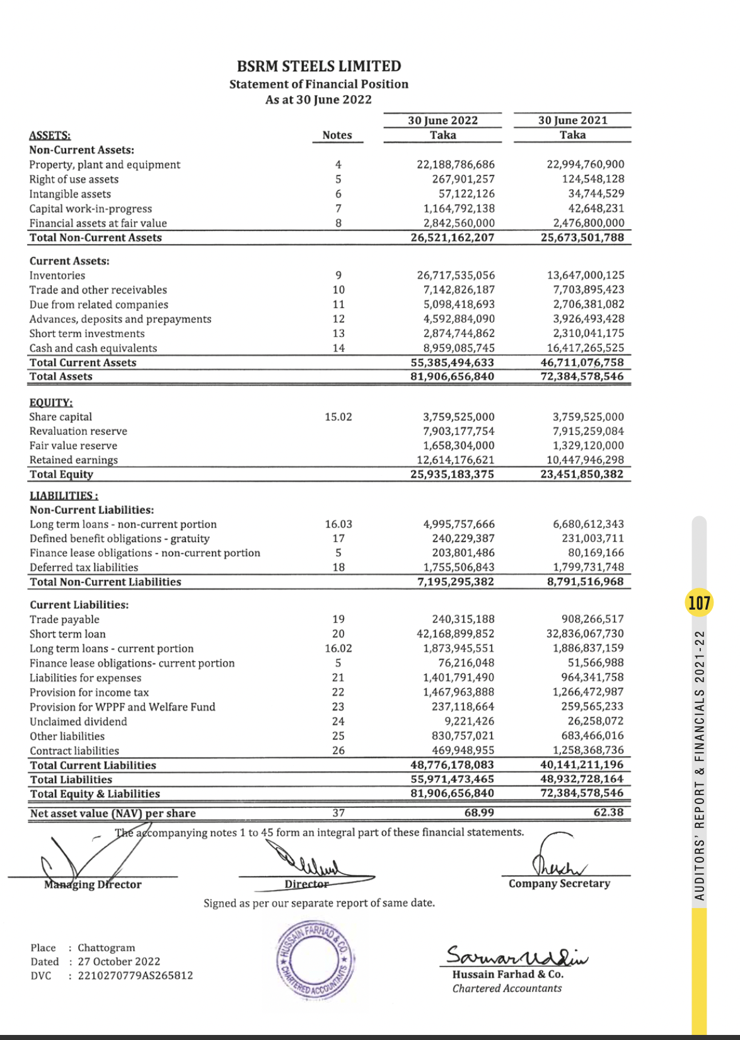

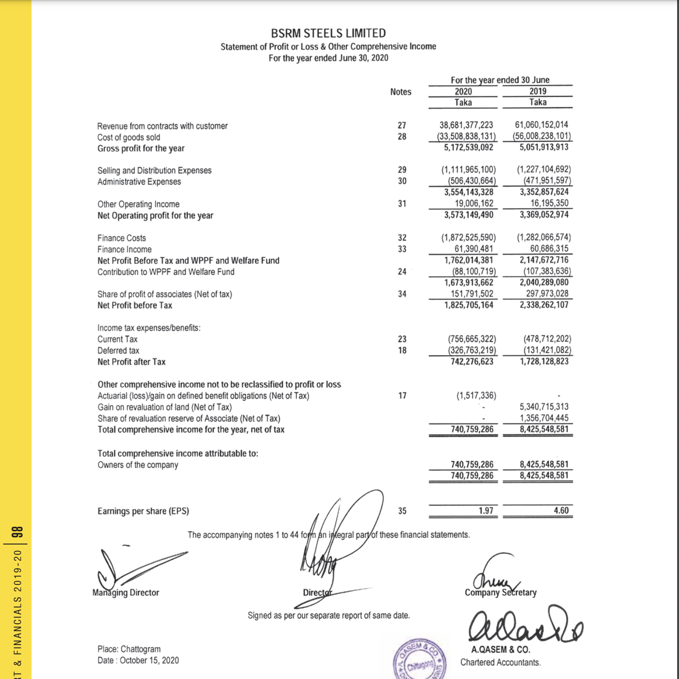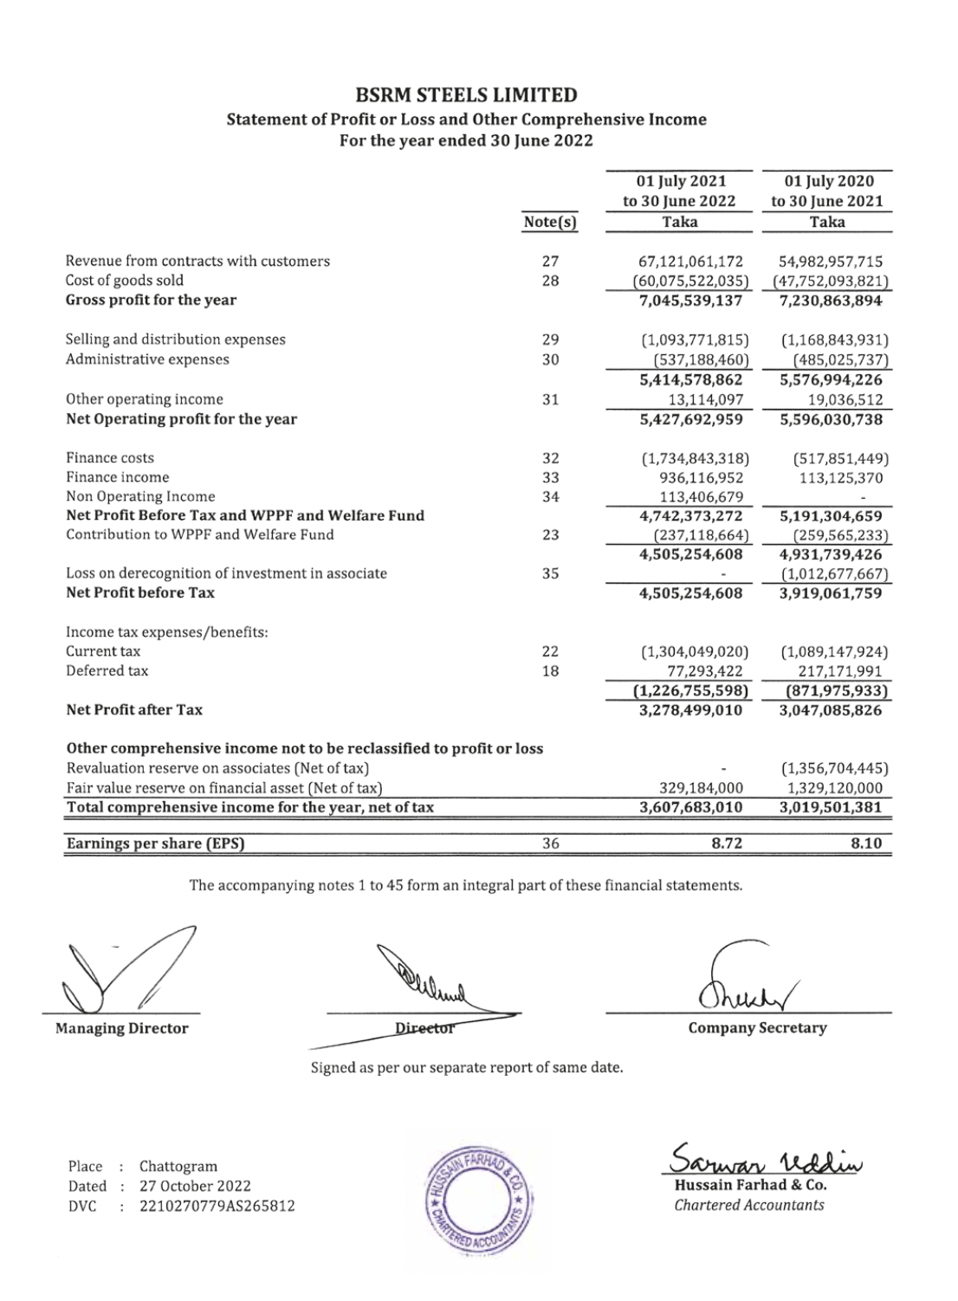

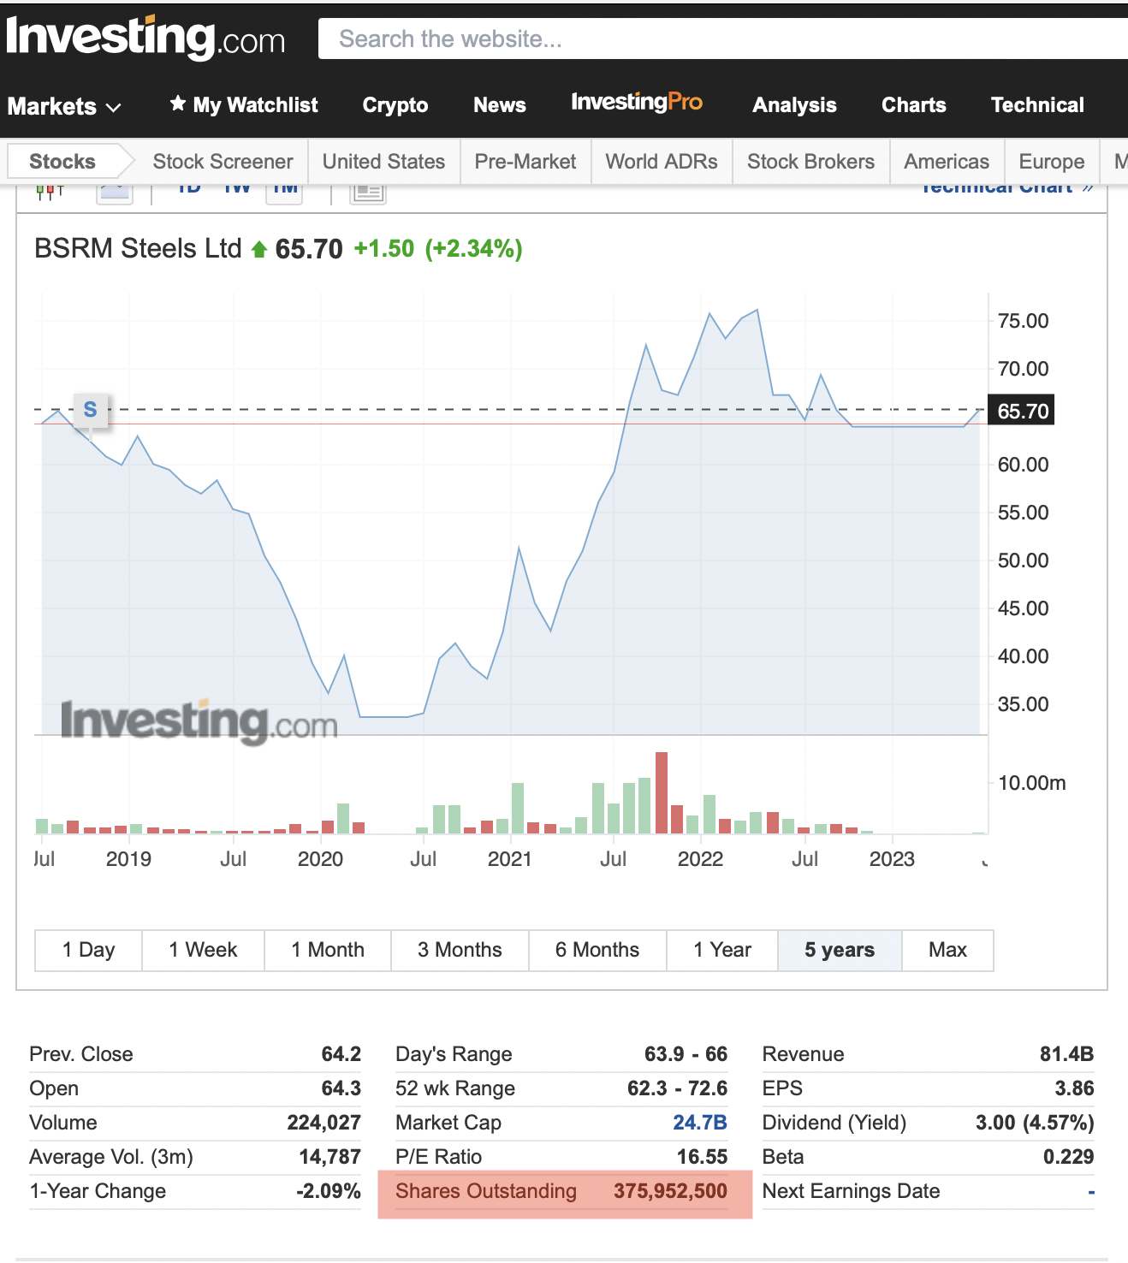

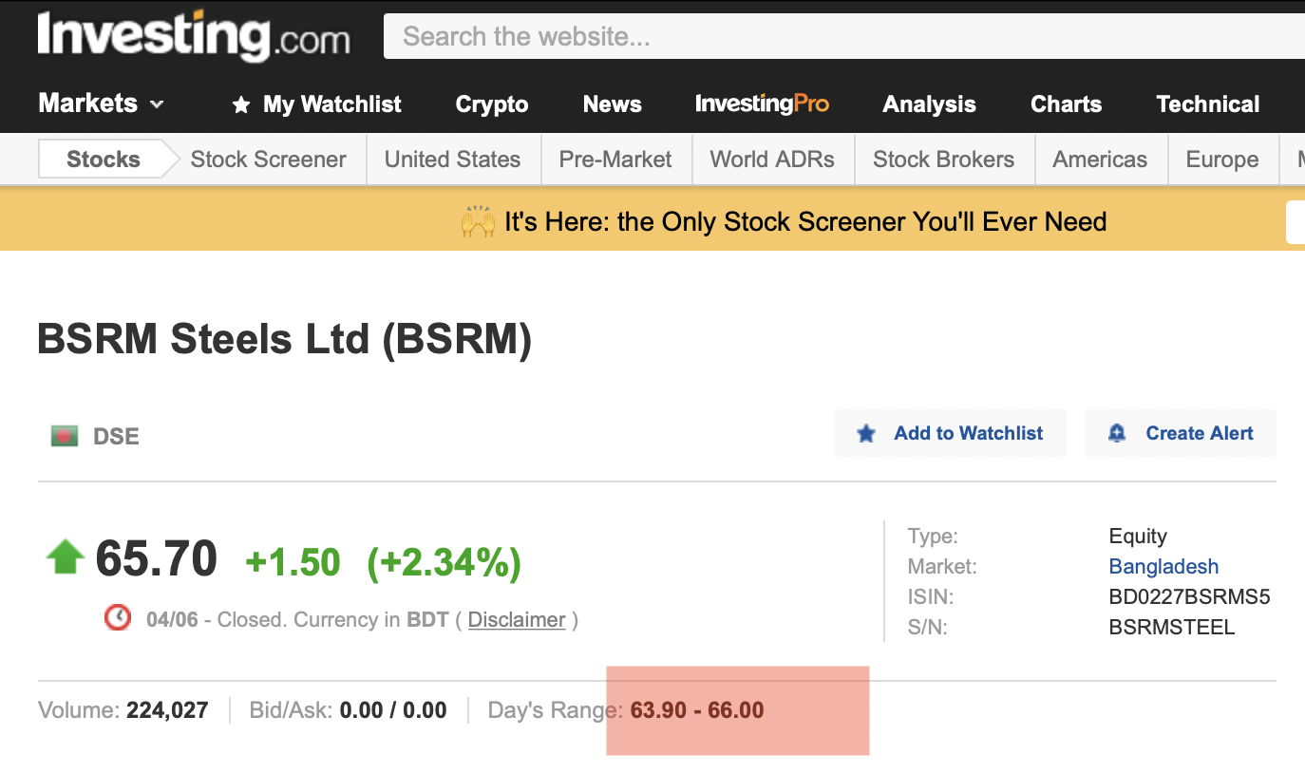

**(GPHI)**

